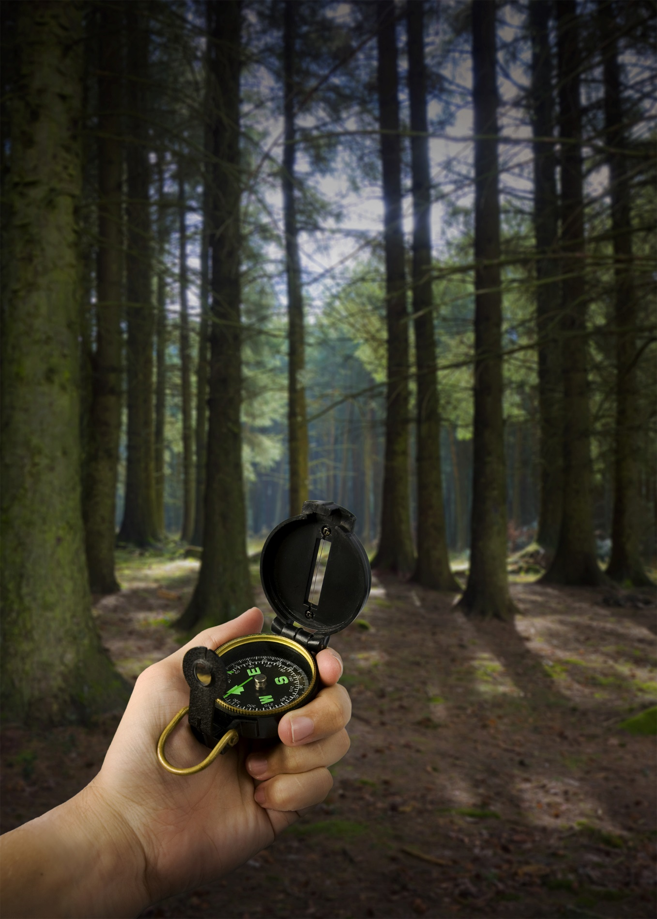
YOUR CONFERENCE

Youth
Ministries
Management
System
Step-by-Step Tutorials

YMMS Step-by-Step Tutorial
Content:

Create A Director/Secretary Account
Staff/Parent Manual Club Registration
Staff/Parent Self Club Registration
Activate/Inactivate Club Members
Change Your Password Director/Secretary
Add Events to Your Calendar
Create A Class/Unit and Add Members
Record A Member’s Progress
Check Class Level Progress
Update Ex-Director/Secretary’s Status/Role
Grant Access To Staff/Parents
Staff/Parent Access and Navigation
Page 3
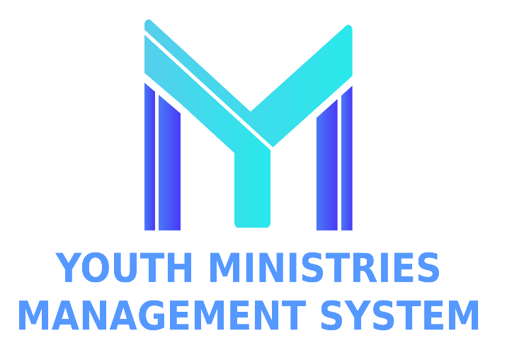
Page 4
Page 5
Page 6
Page 7
Page 8
Page 9
Main Website: NADYouth.com
Need Help: Help.NADYouth.com
Page 10
Page 11
Page 12
Page 13
Page 14
CREATE A DIRECTOR/SECRETARY ACCOUNT
Requirements  It is required to complete the training and background check and visit Adventists Screening Verification (https://t.ly/3cBrb).  - Only for Club Director, Assistant Director, or Club Secretaries  - Date of Birth of Staff.  - Email Address.  Background Check Eligibility Date.  - Background Check exact name used.  Example - Go to https://t.ly/akmhC  - Approved Driver Questionnaire Form if they will be a Volunteer Driver.  - Emergency Contact Name/Phone. | Step 1  Log into your YMMS account at NADYouth.com | Step 2  Click the “Request/Reactivate account” button on the login screen.  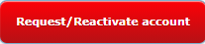  This is the first step to starting your club for the current year cycle in YMMS.  If you are a new club leader, you must request a new YMMS account.  Established club leaders will need to  reactivate their accounts.
Step 3  In the Request Type, select “I don’t have a login to the YMMS”.  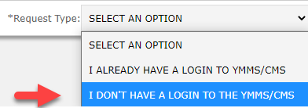 | Step 4  Fill out ALL the information requested. Read the Privacy Policy and Terms of Use. Check the box “I accept the Terms” and click SUBMIT.  It will take 7 to 10 working days for your Conference personnel to validate/accept your request; please plan accordingly.  Note: The following should not request an account in YMMS themselves. Conference Staff, Area Coordinators, All other Club Staff, Club Members, and Parents. | Important  YMMS will match the user’s (1) Name, (2) Birth Date, and (3) Background Check Verification Date with Adventist Screening Verification (https://t.ly/3cBrb) as part of the approval process. The user account will not be approved if these three items do not EXACTLY MATCH. When this happens, the user will be unable to access YMMS and possibly not be able to register for Conference events until the error is corrected.

IMPORTANT AND REQUIRED INFORMATION TO HAVE ON HAND BEFORE STARTING
CLUB STAFF  - Date of Birth of Staff.  - Email Address.  - Background Check Eligibility Date for all Adults.  - If required, Approved Driver Questionnaire form if they will be a Volunteer Driver.  - Emergency Contact Name & Phone.  All volunteers MUST complete the Adventists Screening Verification (https://t.ly/3cBrb) BEFORE they are allowed to serve in your Club and before you can register them in YMMS. | CHILDREN  - Info from Local Club Registration.  - Pathfinder Local Club Reg.  - Adventurer Local Club Reg.  Note: A Pathfinder Club Staff’s child, if in an Adventurer Club, must be registered under both Clubs separately but with different roles in each Club. |  | ADVENTURERS PARENTS  - Date of Birth of Parent.  - Email Address.  - If attending combined Pathfinder & Adventurer overnight local club/conference sponsored events: Background Check Eligibility Date is REQUIRED.  - If required, Approved Driver Questionnaire Form if they will be a Volunteer Driver.  - Emergency Contact Name/Phone.  All Staff MUST complete the Adventists Screening Verification (https://t.ly/3cBrb) BEFORE they are eligible to be registered and attend events. |  | PATHFINDER PARENTS &  MASTER GUIDE  - Date of Birth of Parent.  - Email Address.  - If attending local Club/conference sponsored events: Background Check Eligibility Date is REQUIRED.  - If required, Approved Driver Questionnaire Form if they will be a Volunteer Driver.  - Emergency Contact Name/Phone.  All Staff MUST complete the Adventists Screening Verification (https://t.ly/3cBrb) BEFORE they are eligible to be registered and attend events.
Step 1  Log into your YMMS account at NADYouth.com. |  | Step 2  In the Short Cut Menu, go to Members and click on Register, or Under Secretary, click on “C007 – Members” and click New.  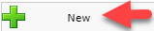 |  | Step 3  Fill out ALL the information requested using the info gathered as detailed above. Make sure to click Save.  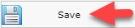
Step 4  The page will refresh, and you can look to make sure your Club Member shows up in the list below. |  | Step 5 (optional)  Click on the magnifying glass icon to view the information you just entered. |  | Step 6  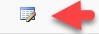  If you need to change your entered information, click the form icon.

STAFF/PARENT MANUAL CLUB REGISTRATION

Set Up - Step 1  Log into your YMMS account at NADYouth.com. | Set Up - Step 2  Go to the "C216 – Enrollment" sub-module under the Secretary module. | Set Up - Step 3  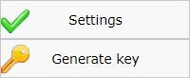  Go to the Settings button and fill in the data about your Club. Check both options for "Club enabled in Find a Club" and "Available Pre-Registration."  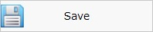  Optionally, you can include a PDF of your club handbook or welcome letter in the "Internal Regulation" as a file upload. Finally, click "Save."
Set Up - Step 4  Generating a key to send to parents and staff is also important. Click the Generate Key button to create a new key.  Now, you can copy the Key and the Club Registration Link in either English or Spanish to send to your parents and staff. | Review Submissions - Step 1  Once a parent or staff has submitted a Registration for your club, it will be listed and waiting for you to approve in the "C216 – Enrollment" sub-module under the Secretary module.  Select the Validate icon to review the submitted application.  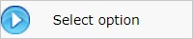  Click the "Select registration option..." and specify if this is a new registration or an update to an existing registration. Then click the "Select Option" Button. | Review Submissions - Step 2  Scroll down and review the information.  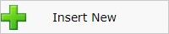  To accept new registrations, click the "Insert New" button.  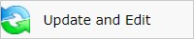  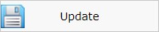  To accept updates, click either the Update Button to accept the new information "as-is" or the "Update and Edit" button to modify and accept the new information.
STAFF/PARENT SELF CLUB REGISTRATION

Step 1  Log into your YMMS account at NADYouth.com. | Step 2  In the Short Cut Menu, go to Members and click on Manage.
Step 3A - Activate  To activate, search for the club member. Change the filter by status Disabled and click the filter data button to apply your filter changes.  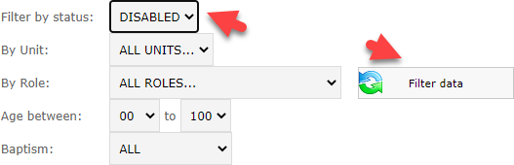  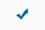  Select the member to be activated and click on the blue checkmark.  Note: no users are completely deleted; their status is changed to "active" or "inactive." Active members are shown in black. | Step 3B - Inactivate  To inactivate/disable, search for the club member. The default search is for only active members. Change the "Filter by status" to "ALL" and click the filter data button to view both active and inactive members.  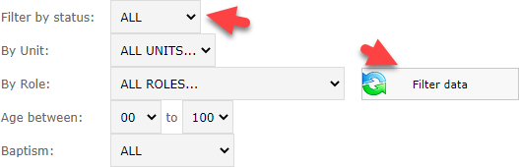  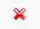  Select the member to be activated and click the red X.  Note: no users are completely deleted; their status is changed to "active" or "inactive." Inactive members are shown in red.
ACTIVATE/INACTIVATE MEMBERS

Step 1  Log into your YMMS account at NADYouth.com. | Step 2  In the bottom right corner of the password, click on Forgot Password.  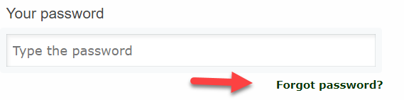
Step 3  Type your email and select your ministry. Then click the send button.  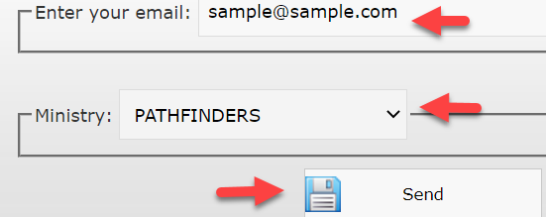  You will receive an error message if you type the incorrect email or select the wrong ministry.  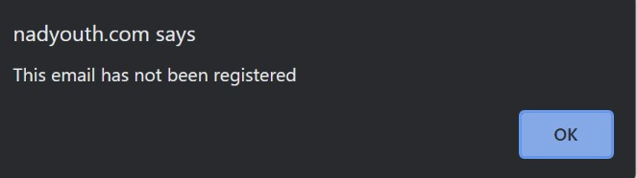  If the information is correct, you will receive an email with instructions. | Step 4  It is important to have a strong password and follow the recommended password guidelines.  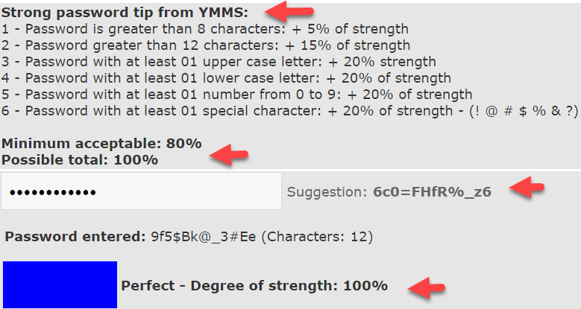

CHANGE YOUR PASSWORD

Step 1  Log into your YMMS account at NADYouth.com. | Step 2  Look on the left-hand side menu, click on  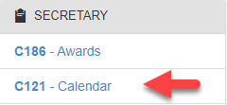  Secretary and then click on  "C121 – Calendar". | Step 3  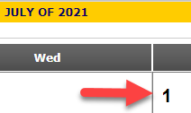  Find the Month you wish to add an event and click on the date number.
Step 4  Add all the required and relevant information. Please be sure to select the correct TYPE of Activity. | Step 5 (Optional)  Set an internal reminder for yourself. Note: A Reminder will be sent ONLY if you chose that option in the email you specified. | Step 6  For additional events, repeat steps 3 to 5 for all your Club Meetings, Local Club Events, and other events.
PRINT THE CALENDAR (GRID)  Highlight/select all the days of the month you wish to Print (press and hold the left button on your mouse and highlight down). Right-click and select Print.  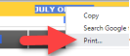 | PRINT THE CALENDAR (LIST)  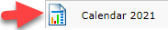  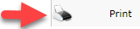  Click on the button at the top right corner. Scroll down to the bottom of the page. | CHANGE OR DELETE AN EVENT  Click on the Event Title in your Calendar, then choose Change or Delete.  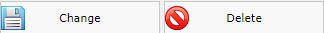

ADD EVENTS TO YOUR CLUB CALENDAR

Step 1  Log into your YMMS account at NADYouth.com. | Step 2  We recommend adding all club staff and members before this step.  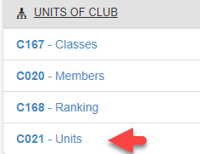  In the left-hand Menu, go to Units of Club and click on Units. | Step 3  On the top right corner, click on  the "+ New" Button.  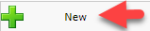  Name each class, for example,  Friends or Helping Hands.  Optional - add an identifier for multiple Counselors/Instructors per class level, for example, Friends Class 1 or Friends Mrs. Smith. | Step 4  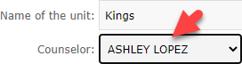  On the drop-down, select the counselor.  Note: Only Counselors already registered in YMMS with the Role will appear as a selectable option.  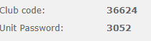  Write down the Club Code and Password for your records and give it to each counselor. Click Save.
Step 5  Once all classes are created with a counselor, click "Units of Club" and then "C020 - Members."  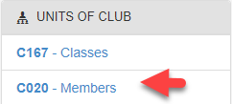  Note: Members must be Registered for Classes and appear on the Class Level Roster. | Step 6  Click on the "+New" button.  Select the Unit from the dropdown.  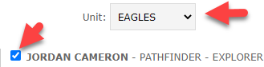  Check the checkbox next to each child’s name who you want to add to that class, and then click Save. | Step 7  Email your counselor the following info:  - Club Code  - Unit Password  - Tutorial - How to… Record Club Member’s Class Level Progress | Step 8 Corrections  If any member was assigned to the wrong Unit  - Go to  "C020 – Members."  - Search for the child in the top section.  - Click on the Red X under the Delete column.  - Start again at Step 6
CREATE A CLASS/UNIT AND ADD MEMBERS

Step 1  Using the Club Code and Password your Director/Secretary has emailed you, please visit the public "Find a Club" side of YMMS:  (English) https://nadyouth.com/club  Then select "Unit Corner".  (Español) https://nadyouth.com/club/es/  Luego seleccione "Rincón de la unidad". | Step 2  You will see the list of members assigned to your class.  Note: If the list is incorrect, contact your Club Director or Secretary to get them assigned correctly.  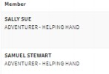 | Step 3  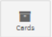  On the right-hand side, click the Cards Icon to access that member’s Class Level Cards.  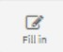  Click on the "Fill in" Button for the Class Level you are responsible for teaching.
Step 4  For each requirement, fill in the Date of Completion and any Comments.  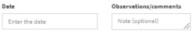  You can always return to edit the Card within the club year.  Note: Directors and Secretaries can access to verify % of completion for each member directly. | Step 5  Save the updates regularly by clicking the  "Update Card" Green Button.  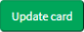 | Step 6  To update someone else’s card, click on the "Previous Page" Blue Button to return to the list of class members and follow step 3.
RECORD A MEMBER PROGRESS

Step 1  Log into your YMMS account at NADYouth.com. | Step 2  Go to Units of Club in the left-hand Menu and click on Classes.  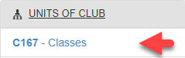 |  | Step 3  Check Progress by:  Group - All in one Class Level and then members within that Class Level.  Individual - Individual members for ALL Class Levels they have participated in and then Individual Class Level.
Step 4- Group  After Step 2, To see the progress of all the Club Member for a Class levels, scroll down to the section Classes, and click on the magnifying glass icon under the Members column.  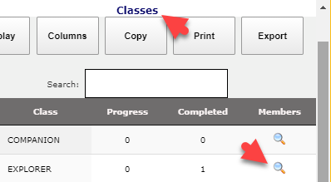  If interested in a member’s progress, click the magnifying glass icon under Card. |  | Step 5 – Individual  After Step 2, To see the progress of the Club Member for all Class Levels at once, scroll down to the section Members and click on the magnifying glass icon under the column Card.  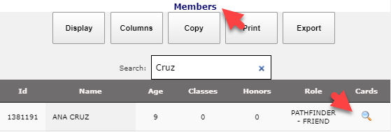  If interested in a member’s progress, click the magnifying glass icon under Card.

CHECK CLASS/UNIT LEVEL PROGRESS
Step 1  Log into your YMMS account at NADYouth.com. | Step 2  In the shortcut Menu, or under Secretary, go to Members. Search for the Director or Secretary's name.
Step 3A  Ex-Director/Secretary leaving the club  If the Past Director or Secretary is not staying with the club as a staff or parent, inactivate the user by clicking the X icon.  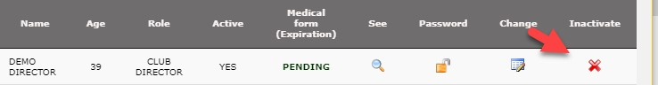 | Step 3B  Ex-Director/Secretary staying with the club  If the Past Director/Secretary is staying with the club as staff/parent:  On the column called Change, click on the Edit Icon.  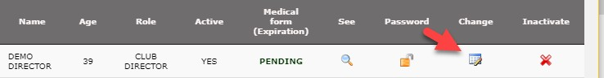  Update the new role and accept the terms.  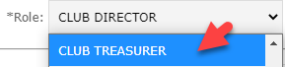  Note: If you need them to have Club Staff access, please follow the "Grant Access to Staff/Parents" Tutorial.

UPDATE EX-DIRECTOR/SECRETARY’S STATUS/ROLE

Important: Staff/parents will ONLY have access to the Library of Class Requirements and Honors/Awards. This is an optional resource.  GRANT ACCESS TO STAFF/PARENTS  - If a Staff/Parent is already part of Adventurer and Pathfinder or Master Guide club, it is not necessary for them to have more than one account because the library includes access to Adventurer, Pathfinder, Master Guide, Class, and Honor/Award requirements together.  - We recommend Usernames be very specific to the person and club.  - We recommend users to update their password using the tutorial titled "Change or Reset Password".  - Copy all the info you created BEFORE clicking SAVE as it will lock you out once you click save creating the user account. | Step 1  Log into your YMMS account at NADYouth.com. | Step 2  On the left-hand side menu, click on Secretary and click on C007 – Members.  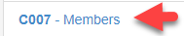 | Step 3  On the right-hand side, you can search for the staff/parent.  Then click on the Lock Icon.  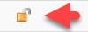
 | Step 4  Create the Username, for example, PFJaneDoe.  Note: It is optional to add PF, Adv, or MG to the Username; this will be for access control. | Step 5  Create the Password following the requirements.  Note: You can double-check/copy the password by looking right under the password text box. | Step 6  Copy the Staff/Parent Username and Password for your records, then click Save.  Note: You should have this information if the user forgets their username. If the user needs to reset their password, use the  tutorial “Change or Reset Password.”

Step 1  Log into your YMMS account at NADYouth.com. | Step 2  Use the Username and Password that your director/secretary emailed you.  The system will ask you to update your  password.  NOTE: If the system pop-up mentions, "The user does not have an email," please provide your email to your director or secretary; they will update your records. | Step 3  As a Parent / Club Staff, you will have limited access to general information.  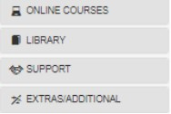  Your Club Director may ask you to visit the library for resources.  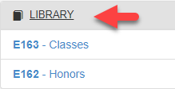
Classes  Classes refer to the Pathfinder and Adventurer Class Levels. Here you can check the requirements for each class.  Click on the search icon to see the specific  requirements. | Honors  In Honors, you will find the requirements and answers to Master Guides/Pathfinder Honors, Adventurers Awards, Chips, and Stars from the NAD and other conferences (as they are added into the system).  Click on to search icon to see the specific requirements. | Advanced search  You can search for specific Honors, Awards, Chips, or stars using the Search bar.
STAFF/PARENT ACCESS AND NAVIGATION

